**Chapter 3**

**METHODOLOGY**

**Introduction**

The Philippine Grain Standardization Program is a government program spearheaded by the National Food Authority to provide commercial assessment standards for the determination of the grade and quality of milled rice products. The implementation of the program started on September 21, 2002. From its establishment, the National Grains Standard has been formed. The National Grains Standards defined the characteristics classification of the rice grain samples. Factors for determining grade include dimensional length, degree of milling, percentage by weight of broken kernels, brewers, red kernels, immature kernels, chalky kernels, damaged kernels, yellow kernels, age-related changes, and other characteristics.

The grades are based on the percentage by weight of the classified grains to the overall weight of the product. The Grade 5 is the lowest and the Premium grade is the highest grade a milled rice product can be classified to. Moreover, the implementation of these standards in the market is expected to boost the quality of the rice products in the Philippines.

The purposes of this study are to lessen the subjectivity of rice grading assessments based on the National Grain Standards by utilizing the consistency and precision of computer-aided assessments and to speed up the grading time. Using image processing methodologies, the study aims to develop a milled rice grading system that is portable and accessible to people and organizations who are working directly on rice like millers, distributors, and farmers. The main parts of this study are directed towards the gathering of the qualitative reference values set by the NGS and the rice quality assessors; creation of a portable standalone device equipped with image analysis software that grades the rice samples based on an image of non-overlapping grains; and the display of the grade report. Activities performed by the image processing application include the counting and dimensioning, color analysis, grain classification, averaging, and grading.

Figure. The Conceptual Framework

The portable automated grading system grades the rice grain samples based on their features and characteristics. The input to the system is an image of non-overlapping rice grains illuminated by a constant setting light source and special image acquisition platform designed to minimize variation in perceptual characteristics. The processing will begin by subtracting the background of the image to segment it. Pixels signifying grain will remain while non-representative pixels will be converted to black pixel values. Furthermore, using connected component labelling, the representative pixels will be labelled into neighbors with each neighbor representing a single grain. The labels act as counting mechanism. For each grain, a label is assigned (e.g. 1, 2, 3, 4, etc.). The grain count will be obtained during this process. The individual analysis of grains will begin afterwards.

For every single grain, a dimensioning algorithm is performed to measure the major axis length. After dimensioning, the color analysis will be performed. In the color analysis, some color channels will be compared to reference values obtained from the NGS and the rice graders. Once the color analysis and dimensioning are done, the average length of the sample is obtained. The grain classification process has two parts: (a) grain size classification and (b) grain type classification. In the grain size classification, the size of the grain is compared to the average length of the sample. The system will classify the grain into broken, brewer, or regular. In the grain type classification, the system will classify the grain into immature, red, or yellow kernel.

After analyzing color channels, the rice grain samples will be processed through thresholding to segment regions indicative of bran presence and chalkiness. The areas of the bran and the chalky regions are obtained. They will be compared to the overall area of the grain. After the area analysis, the degree of milling and the chalkiness degree are obtained.

The analysis performed are going to be used for averaging. The average length indicates the grain size. The count of the brewer and broken grains are also used. The percentage by weight of the immature, red, and yellow kernels are obtained by getting the percentage of each grain types to the total count of the rice grain samples. The degree of milling and the chalkiness degree are obtained by regional area percentage.

The data obtained from the image processing methodologies are compared and classified into grades based on the National Grain Standards. The system will display these determining factors along with the grade of the rice grain samples. The grade of the samples ranges from Grade 5 being the lowest to Premium as the highest grade a sample can be classified to.

**Determination of Reference Values**

With the traditional method of grading rice, the qualitative factors (e.g. immaturity, yellowness, etc.) rely on the expertise and perception of the assessor. Moreover, the National Grain Standards provided qualitative measures for assessing a rice grain. An example of this is the chalkiness of a grain. The NGS defined the color of the chalky region as ‘white as a white chalk’. Before doing the image processing, the system needs to obtain the reference values that would indicate the mentioned qualitative characteristics.

The following factors are qualitative in nature and the reference values need to be obtained from the NGS and a certified grade assessor: (a) degree of milling, (b) immaturity, (c) chalkiness, (d) redness, and (e) yellowness. Since the image acquisition platform provides constant lighting settings and reduce outside light interference, the color model that will be used is the RGB color model in 8-bit JPEG images.

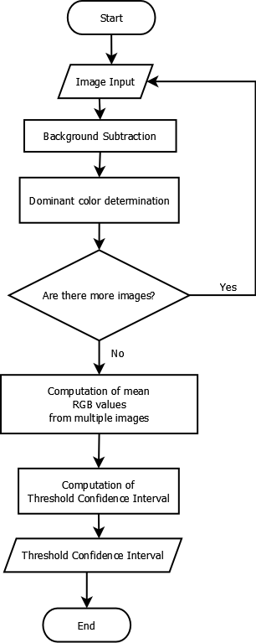

Figure. The process flowchart of the determination of threshold confidence interval

Multiple images of multigrain samples are fed to the system. A threshold will be applied to the image to binarize the image into zero (background) and non-zero pixel data (colored pixel). For a certain qualitative type (e.g. immature kernel, yellow kernel), the median red, green, and blue channel values will be determined. The obtained value is the dominant color. The mean dominant color will be used to compute the threshold confidence interval. The computed interval will be used as the reference value for the classification.

The median RGB values (dominant color) can be obtained by averaging the R, G, and B values of all non-zero valued pixels. The process is described by the equations. These means describe the dominant color.

$$\overline{R}=\frac{1}{WL}\sum_{i=0}^{W-1}{\sum_{j=0}^{L-1}{R_{(i,j)}}}$$

$$\overline{G}=\frac{1}{WL}\sum_{i=0}^{W-1}{\sum_{j=0}^{L-1}{G_{(i,j)}}}$$

$$\overline{B}=\frac{1}{WL}\sum_{i=0}^{W-1}{\sum_{j=0}^{L-1}{B_{(i,j)}}}$$

$$D=(\overline{R},\overline{G},\overline{B})$$

Where $\overline{R}$ = mean red

$\overline{G}$ = mean green

$\overline{B}$ = mean blue

R = the red channel value

G = the green channel value

B = the blue channel value

W = width of the image measured by pixel

L = length of the image measured by pixel

D = dominant color in RGB format

The process will be applied to the reference values determination for the immature, yellow, and red kernels. However, the degree of milling and the chalkiness reference intervals are obtained by computing the distribution of the regions. For chalky regions, samples of grain images with chalky regions are analyzed. Using thresholding, the chalky ‘white’ defined as ‘white as a chalk’ by NGS and assessors is determined. By isolating the chalky regions, the process for getting the other reference intervals can be used. The same also applies to the degree of milling where the reference intervals of the bran regions are obtained.